**Name: HARNAM KAUR Enrolment No: 00423207218 Class: CSE1**

**MACHINE LEARNING LAB (EXPERIMENT NO 2)**

**AIM:** STUDY AND IMPLEMENT THE DECISION TREE CLASSIFIER ON THE BREAST CANCER DATASET USING SCIKIT LEARN IN PYTHON.

**Program Code Snippet**

**Loading Dataset**

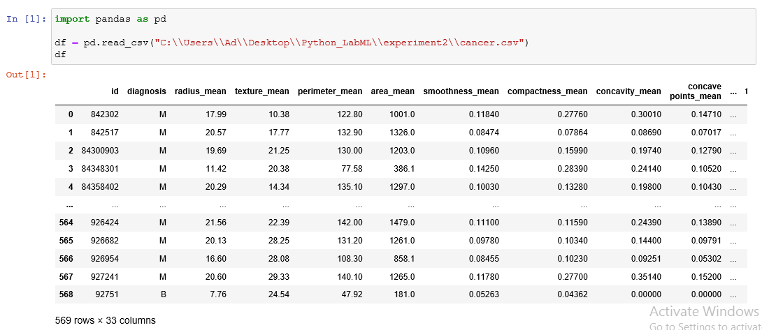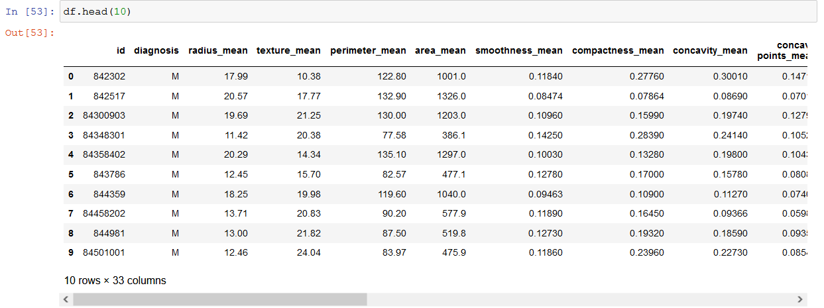

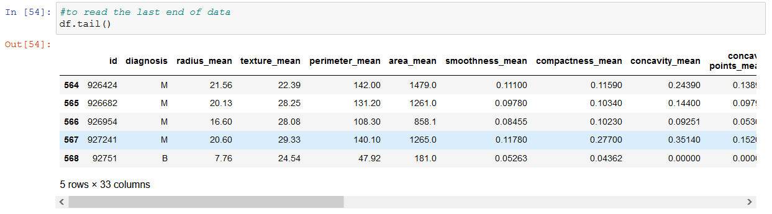

**Preprocessing/Cleaning of dataset**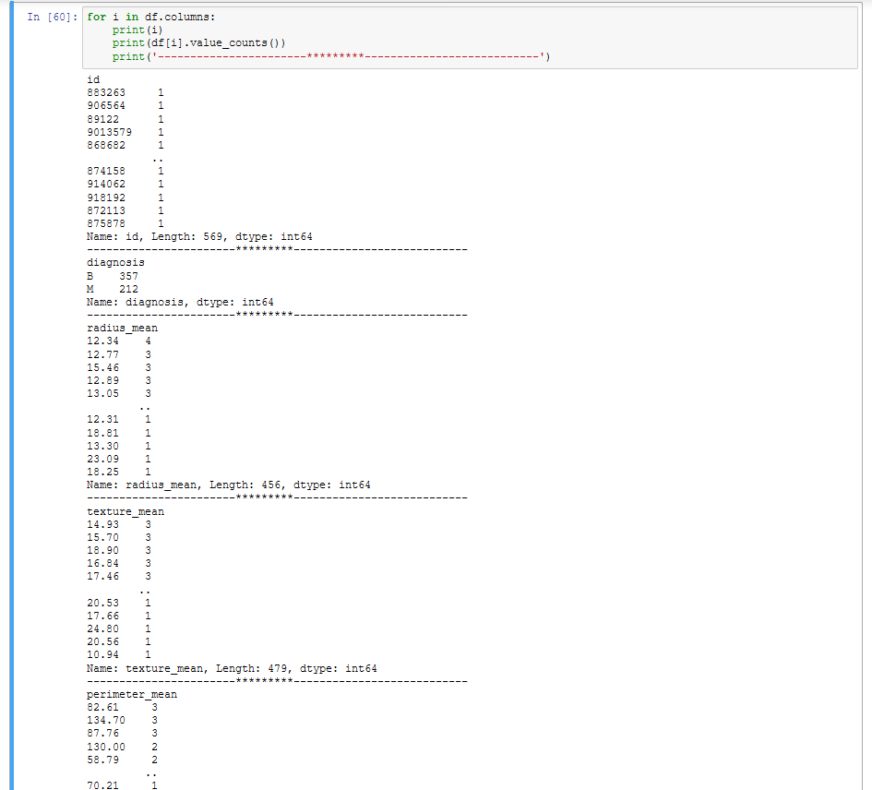

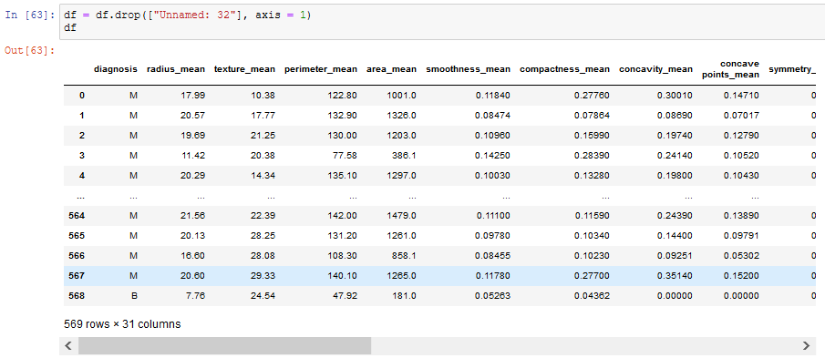

**Visualization**

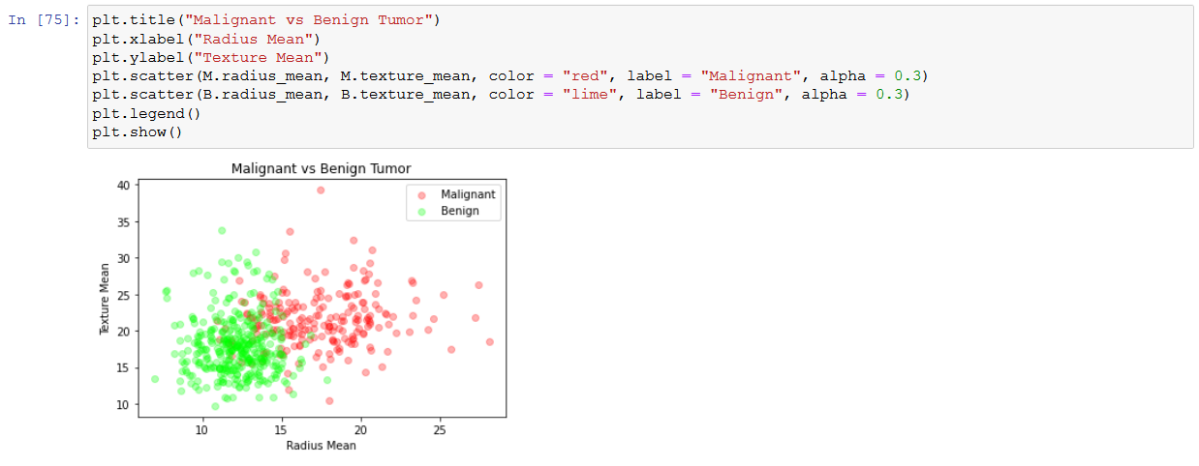

**ML algorithm implementation of prediction or comparison**

Decision tree models where the target variable uses a discrete set of values are classified as Classification Trees. In these trees, each node, or leaf, represent class labels while the branches represent conjunctions of features leading to class labels.

A decision tree where the target variable takes a continuous value, usually numbers, are called Regression Trees. The two types are commonly referred to together at CART (Classification and Regression Tree).

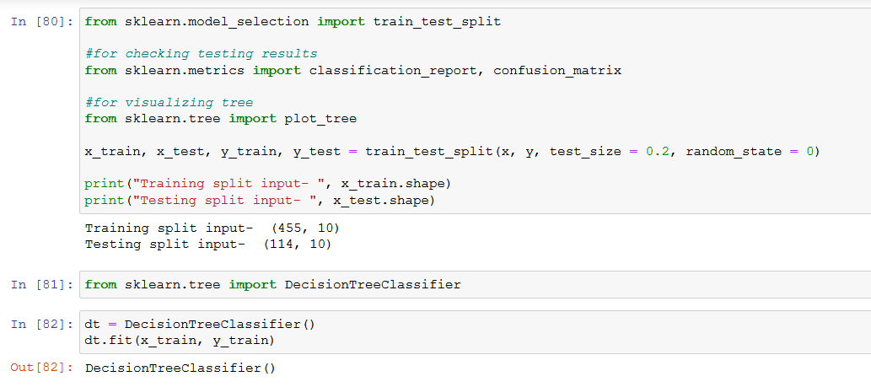

**ROC/AUC/Confusion matrix**

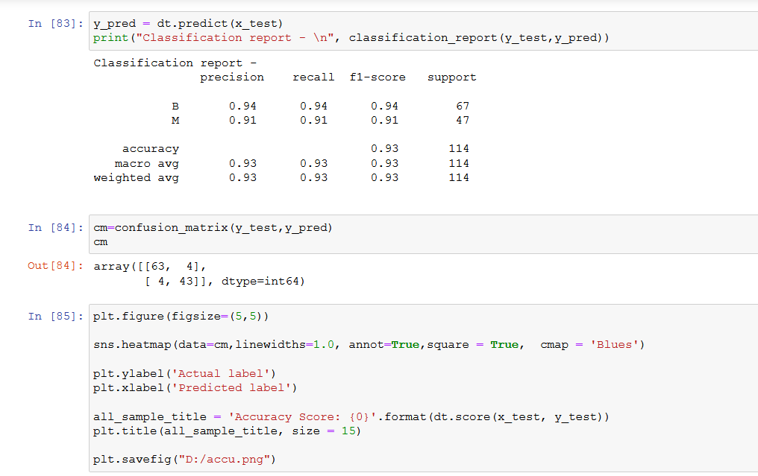

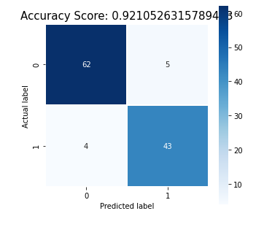

**Final graph**

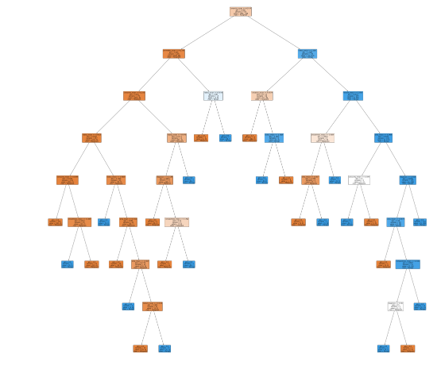

**Github Link of Jupyter Notbook:**

<https://github.com/Harnam99/Lab-Program-2->

<http://localhost:8973/notebooks/Experiment%20No2.ipynb#>

<https://github.com/Harnam99/Lab-Program-2-/blob/main/Experiment%20No2.ipynb>